# Aycada Simulation Game for Production and Capacity Management

## Examination: Decision Paper of the Product Manager

Name: Annika

Surname: Vrbsky

Group (D1, D2, D3 or BWL/Block):E2

Companies (C1, C2, ... C11): Company 3

## Situation

The Executive Board makes monthly decisions on

* The planned production volumes for the four products offered by the company [PU/month] and
* The planned production capacity for the four production stages [hours/month].

Each month, the Executive Board as a body must therefore make eight individual decisions. The first decision is made for month 36.

Each board member has the task of creating a decision template, which serves in particular to support the first joint board decision for month 36. This paper answers the following questions:

## Questions

### Is it economically advantageous to offer the product? (2 points)

Yes, it is economically advantageous to offer product 4. Not only is the contribution margin after deducting all variable costs (Variable manufacturing costs + Variable sales and admin costs) positive. Even when conducting a Breakeven analysis and deducting the Full total costs allocated to each PU, the product’s contribution margin remains positive with a CM of 4,98€ per PU (which translates into a 21,7% “margin”). Insert another screenshot here

At this point however, it must be pointed out that if order backlogs continue to increase, as happened recently due to backlog costs (EUR2.09) being lower than inventory holding costs (EUR3.28), the fill rate will further decline, resulting in order cancellations, higher backlog costs and ultimately less demand. Accordingly, a breakeven analysis, where backlog and inventory holding costs are included in fixed sales and admin costs, might not end up positive anymore.

Nevertheless, a learning rate should be considered. Due to a lack of past data with regards to the cost structure, the learning rate cannot be calculated here. However, it is logical that with a higher cumulated number of produced units, the manufacturing time per PU decreases. As a result, assuming production quantity remains stable, the required production capacity shrinks. Consequently, Fixed Production Capacity costs, which are variable over time, will presumably be lowered. Therefore, the allocated Fixed Production costs per PU will decrease and production of product 4 will become even more economically advantageous.

### Are there time-dependent patterns in past demand (measured in packaging units of the product)? (2 points)

Time-dependent patterns in past demand could generally display seasonal / cyclical behavior, changes could be of similar size, and patterns could be identified in relation to factors such as order backlogs.

When comparing product 4 to product 1-3, it becomes apparent that demand in P4 is very stable. While especially product 1 shows significant seasonal patterns, demand in product 4 demonstrates a positive linear trend. Despite some dips in demand, there seems to be no regularity regarding the dips at first sight.

The screenshot below depicts incoming orders in product 4. When scanning for regularly occurring dips in demand, there sometimes are significant downturns (as in month 14, -6,735 PU, for instance), whereas at other points in time, they are much less extreme (month 26, -2,398 PU, for example). Focusing on the number of months between the dips, one can see that these sometimes occur with only one month in between, as in months 10 and 12, for instance. Conversely, at other times, demand develops positively or stable for 6 months (months 15 – 21) before experiencing a negative shock (month 22, in this case).

Lastly, order backlogs, hence a lower fill rate and decreased customer satisfaction, can be taken into account. As shown in the screenshot below (comparing demand trends with order backlogs), there is no apparent pattern, as for now. This is most likely due to the fact that the clients, wholesalers in this case, have a relatively long reaction time. Hence, negative effects on demand will presumably develop during the next months with the fill rate currently being at only 64.3%, resulting in little customer satisfaction.

To conclude, there are no regular time-dependent patterns by now.

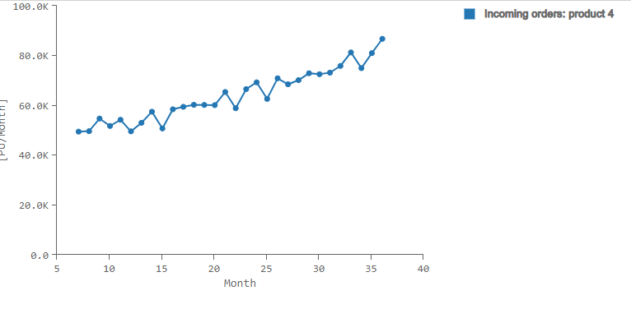

### Which forecasting technique is best suited to provide the most accurate prediction of demand for the product? (2 points)

To begin with, it shall be clarified that forecasts and estimates can always be based on qualitative and quantitative data. With qualitative data available, one could assess the quality of management, foresee large deals with key customers and incorporate knowledge about industry trends to make forecasts and predict the future demand in a product. On the other hand, different quantitative methods can be used to predict future demand etc.. This undoubtedly is the better procedure in the case we are presented with. For the different products, forecasts can be made either relying on linear or seasonal/exponential functions in excel.

Despite no obvious signs for seasonality in demand for product 4, I back tested both functions. I forecasted incoming orders from month 25 to month 36 and compared this with the actual available data. As shown in the screenshot below, a linear forecast resulted in values being similar to seasonal forecasted values. As this does not provide me with further clarification and as I could not identify any signs which would make a seasonal forecast more appropriate than a linear method, I will use a linear function to forecast demand going forward. Furthermore, demand is likely to decrease due to the low fill rate in the recent 3 months. As linear forecasting provides a more conservative prediction, it is even more logical to use this method.

### How high will the demand be in the month (measured in packing units) in which the production quantity to be determined now is available to be delivered? (Note: To answer this question, use the forecast technique recommended above.) (3 points)

In general, a production quantity which is planned in a month is released one month later. Afterwards, it enters production and is accounted for as WiP inventory for two months (as it stays in quarantine before entering inventory). After being released from quarantine, the products enter inventory and are ready to be delivered.

In our case, as we determine production quantity in month 36, it is released in month 37, then is produced and stays in quarantine until the end of month 38 and finally becomes available in month 39. Accordingly, to determine a production quantity, one must always consider the estimated demand three months into the future.

When using the linear forecasting method described above, incoming orders are estimated to be 84,060PU (also shown in the screenshotted data selection below).



### What is the mean absolute deviation between the actual observed demand for the product and the forecast (both measured in packing units) for months 25 to 36 when the selected forecasting technique is applied? (2 points)

To select a forecasting technique in the first place, I proceeded the way explained in question 3. Please find below a screenshot of the linear forecast vs. the actual data. Correspondingly, I now test for the mean absolute deviation between the actual observed demand and the linear forecast (using data from months 7 – 24) for month 25 until month 36.

To do this, one first calculates the differences in values for each of the months (actual value – linearly forecasted value for month 25 until month 36). With all the deviations available, one then calculates the average of all deviations. For P4, this results in a MAD of 2,847.98 PU.

Actual Data:



Linear Forecast:



Mean Absolute Deviation Calculation:

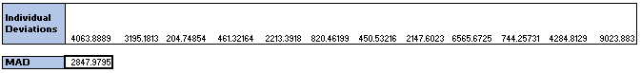

### What quantity of the product (measured in packing units) would you keep in inventory? (2 points)

To begin with, one has to look at inventory holding costs and backorder costs as well as backorder cancellations and the current backorder and inventory statuses to give a proper answer here.

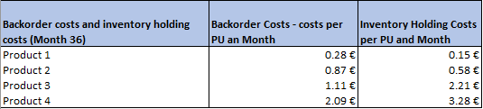

As shown in the screenshot above, backorder costs (EUR2.09 per PU and month) are lower than inventory holding costs (EUR3.28 per PU and month) for product 4. Hence, at first sight, it is cheaper to have a lower fill rate and build a back log, than to overproduce and build up an inventory. While that might be true short term, customer dissatisfaction is going to increase, dragging down new incoming orders in the future. To then win back customers who might have ordered at competing companies instead takes several months. Therefore, there are “indirect costs” due to less overall incoming orders which need to be taken into account here. As shown in the graph below, a Fill Rate of only 64.3% (month 36) results in only roughly 85% of orders usually coming in. Accordingly, this will also reduce operating income in case the lack of demand in product 4 can only be compensated by higher supply of a lower-margin product.

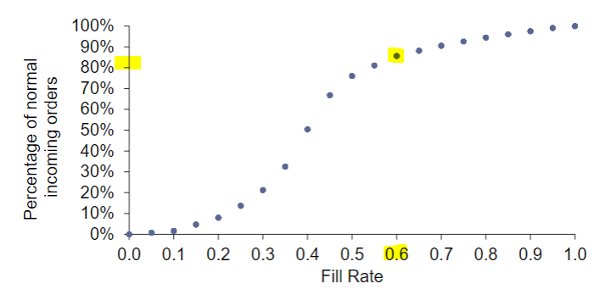

Now looking at the current status of inventories and backlogs, there is no inventory at all and a relatively large amount of backlog (23,973 PU which corresponds to …% of demand during that month. On average, only …% of backlogged orders are cancelled each month. Overall, the fill rate decreased to only..%.

Likely for demand to decrease and for further backlog orders to be cancelled,…

* Weigh inventory costs against backlog costs, plan conservatively, rather some inventory, be safe if demand exceeds forecast
* When?
* Generally, when does one keep products in inventory
* Show fluctuating demand

### What planned production quantity of the product you are responsible for do you propose for month 36? (1 point)

* Excel
* More than demand because of backlog
* Inventory at that point in time, backlogs, demand, backlog order cancellations

### What quantity of the product (measured in packing units) will be in the production and quality control process (WIP – work in process) in month 37? (1 point)

Work in progress inventory generally is composed of the released production quantity from the two previous months. After planned production capacity is released, it must first be produced before being put into quarantine. This process takes two months in total. In this case, one has to add up released production quantities from month 35 and month 36 to obtain WiP inventory in month 37.

Released production quantity in month 35, as given: 71,636 PU

Released production quantity in month 36, as given: 72,214 PU

Total WiP inventory in month 37: 71,636 PU + 72,214 PU = 143,850



## Evaluation criteria

|  |  |  |  |
| --- | --- | --- | --- |
|  | Insufficient | Satisfactory | Very good |
| Correctness of the answer | Answer is grossly incorrect | Answer is partially incorrect | Answer is correct |
| Justification of the answer | No justification available, neither in text form nor as a calculation | Satisfactory justification | Clear and convincing justification of the answer, with calculation (if applicable) |
| Correctness of the data/information used | Incorrect data/information used | Partly correct, partly incorrect data/information used | Correct and appropriate data/information used |